**SMART TABLE SOFTWARE MANUAL**

**Copyright(c) 2017 Gichunge Kim Softwares**

**All Rights Reserved.**

**INSTALLATION:**

-You are issued with a SMART TABLE folder which contains both the SMART TABLE software Installer and Manual.

-Double click on the Installer in the folder or run it as an Administrator

-Choose Your Installation Language

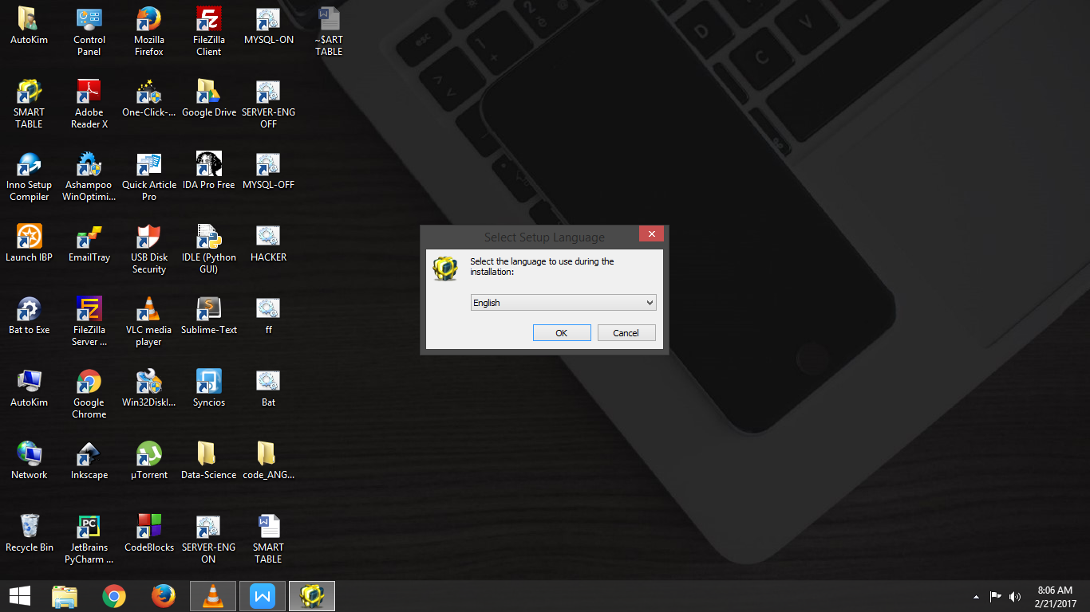

-Accept the License Agreement and Click Next button

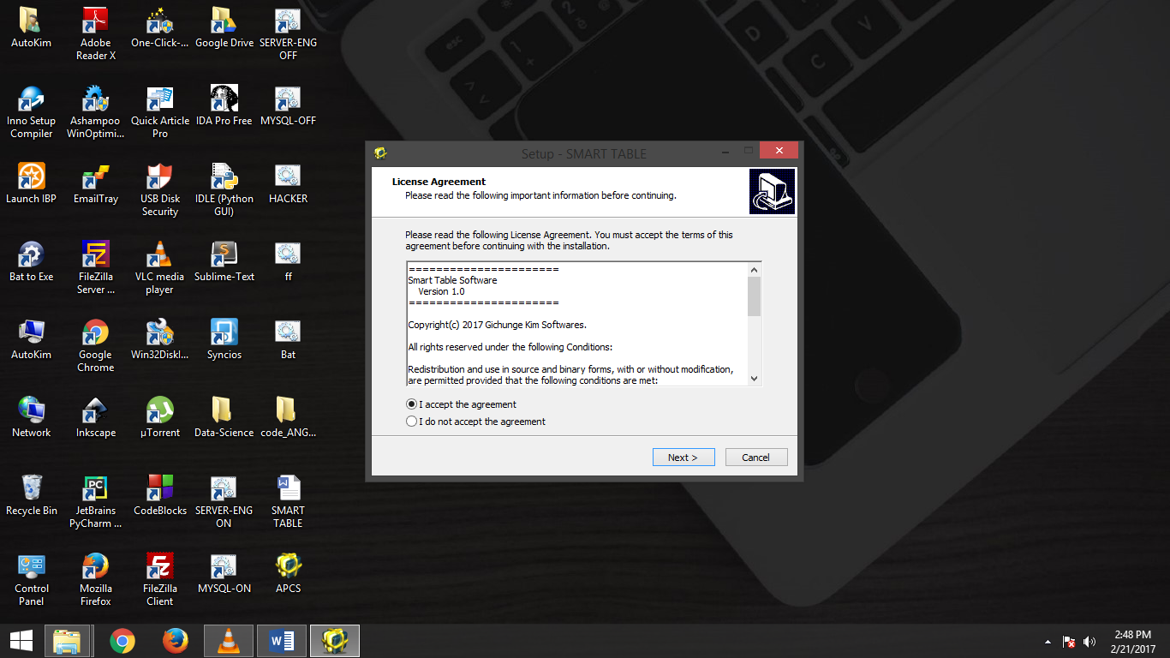

-Select the Installation Folder(Optional), or Leave it as it is(Recommended)

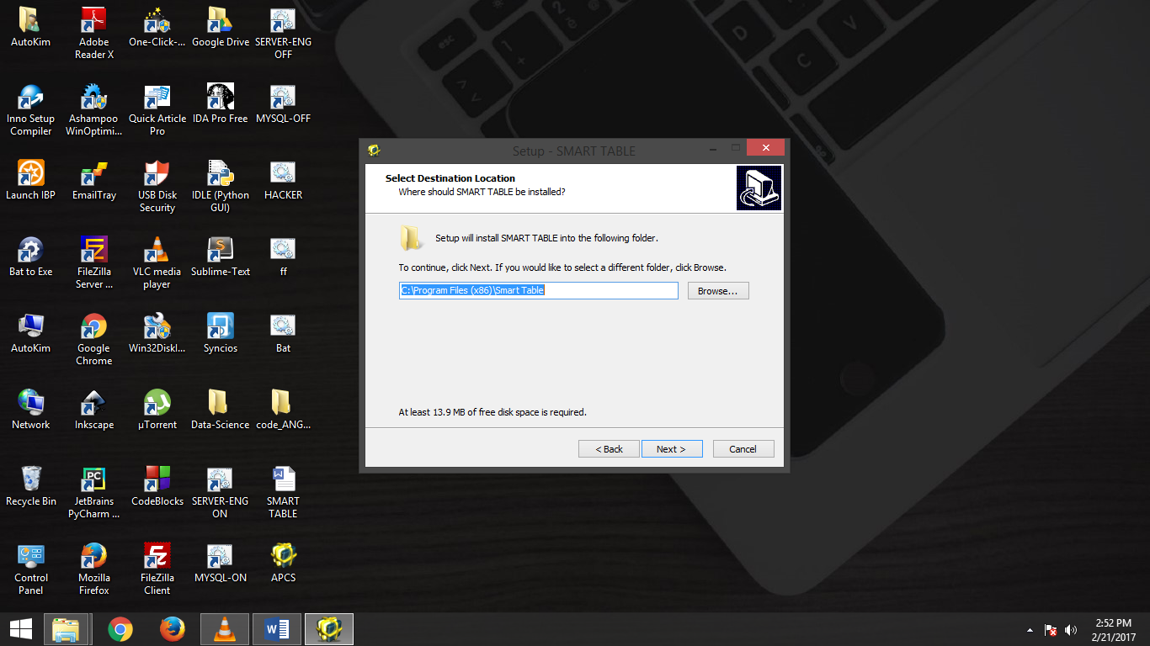

-You can Choose whether to add a Desktop shortcut of the Software for easier access

-Click Next Buttton

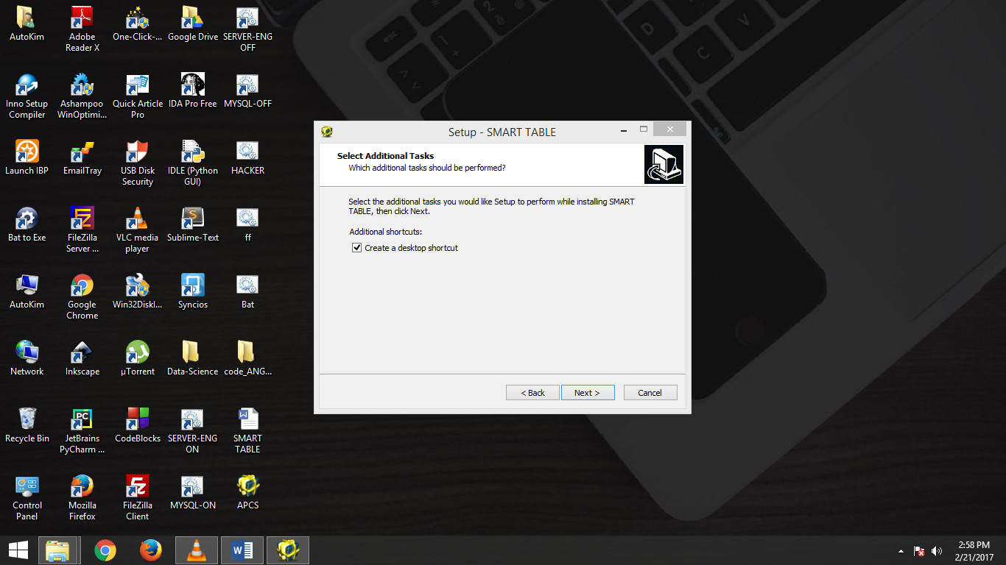

-A window appears that prompts you whether you want to continue Installing the Software

-Click Install Button

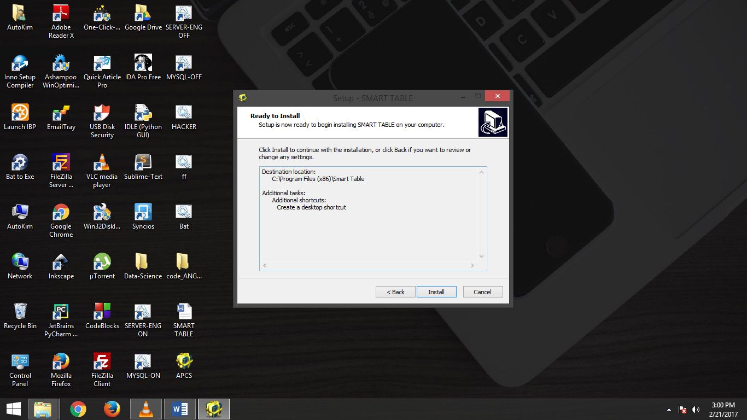

-Give it time as it Installs

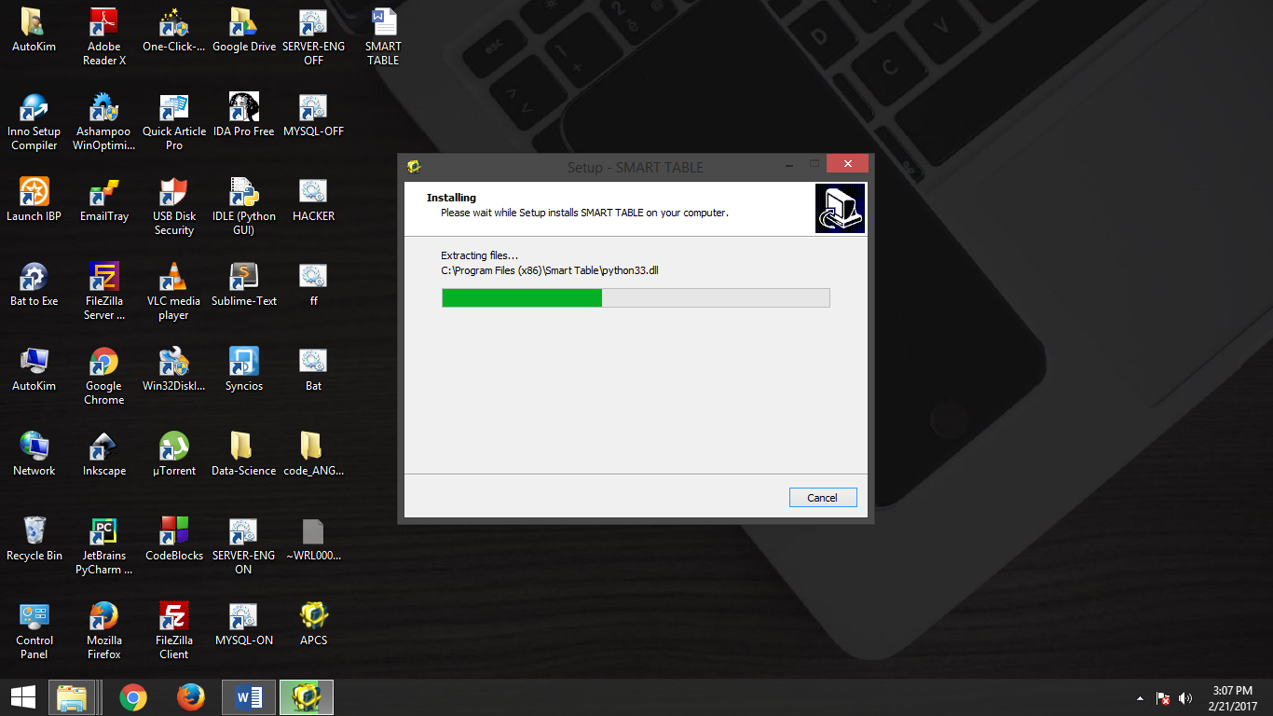

-The setup is complete and you can choose whether to Launch the Software or not

-Click Finish

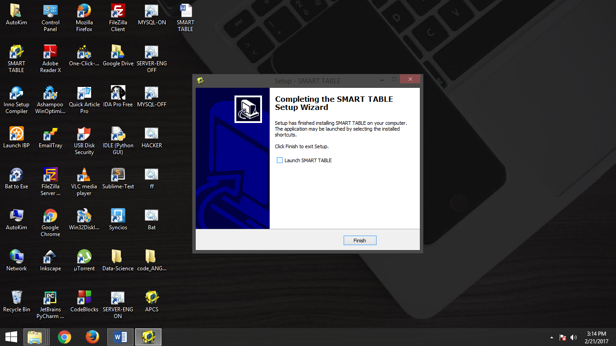

-Navigate to your Desktop and check the SMART TABLE shortcut and DoubleClick it to Run the

SMART TABLE SOFTWARE

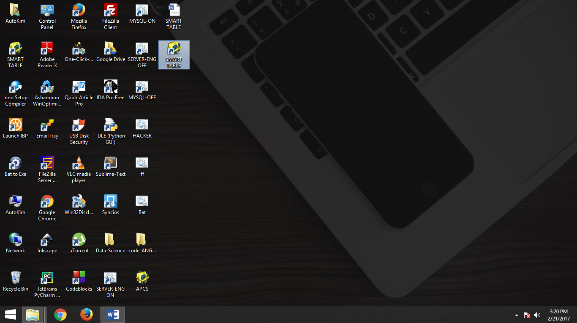

-It is a Console Application(Runs on a window similar to that of Command Prompt)

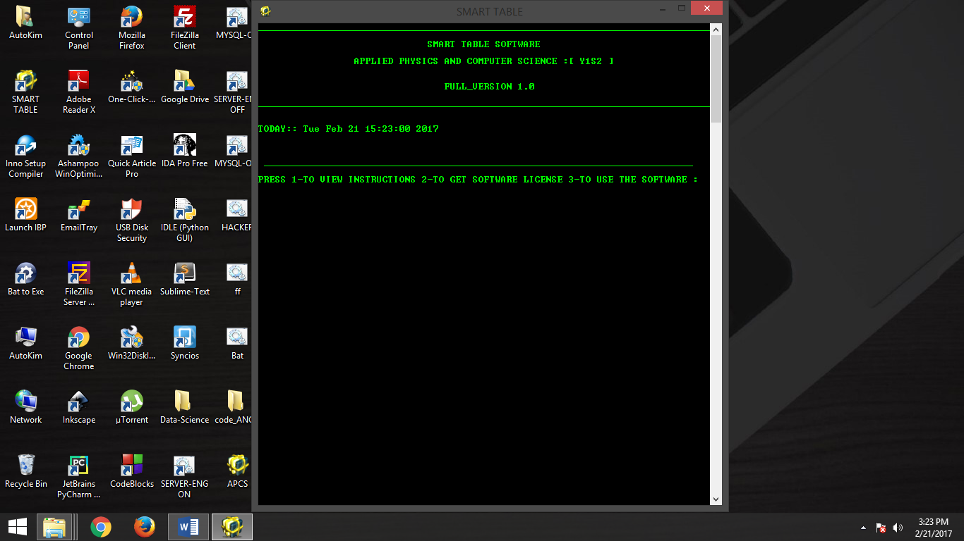

**LAYOUT,FONT AND COLOR CUSTOMIZATION**

-If the initial and default dark background and white font doesn’t satisfy you, you can customize them to whatever you want.

-For Customization,Right click on the SMART TABLE shortcut on the Desktop

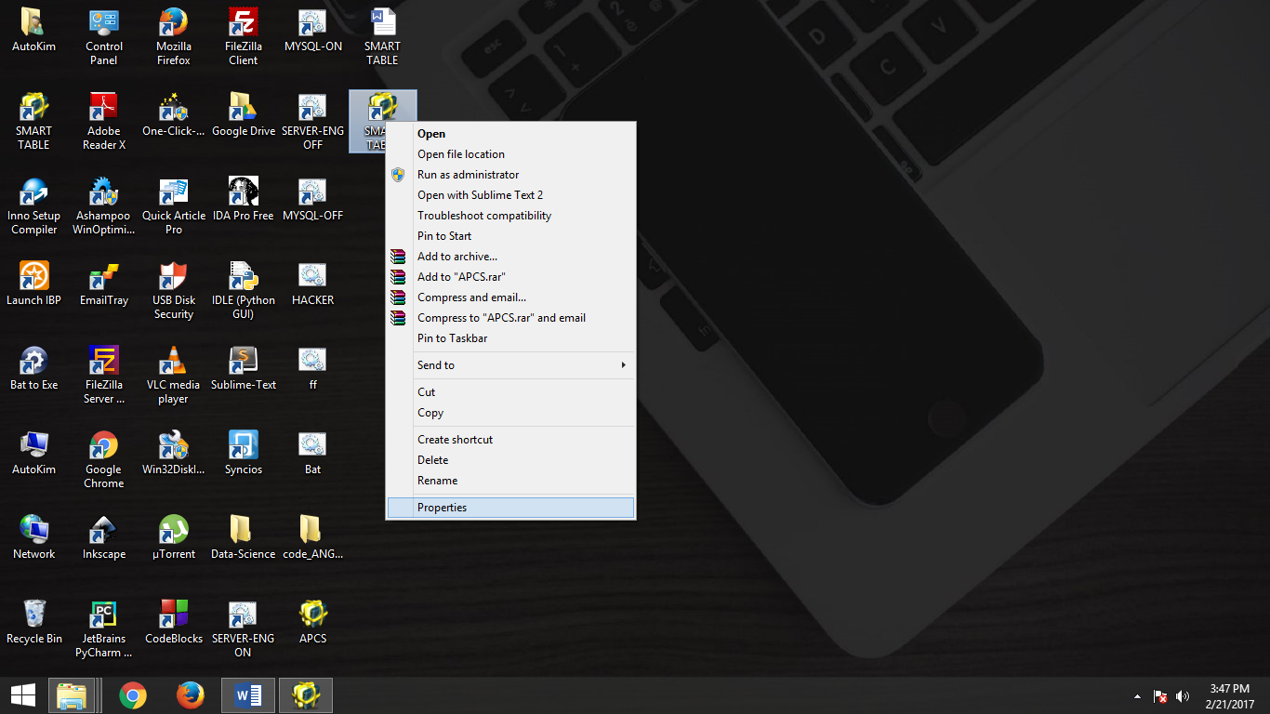

-Click on Properties

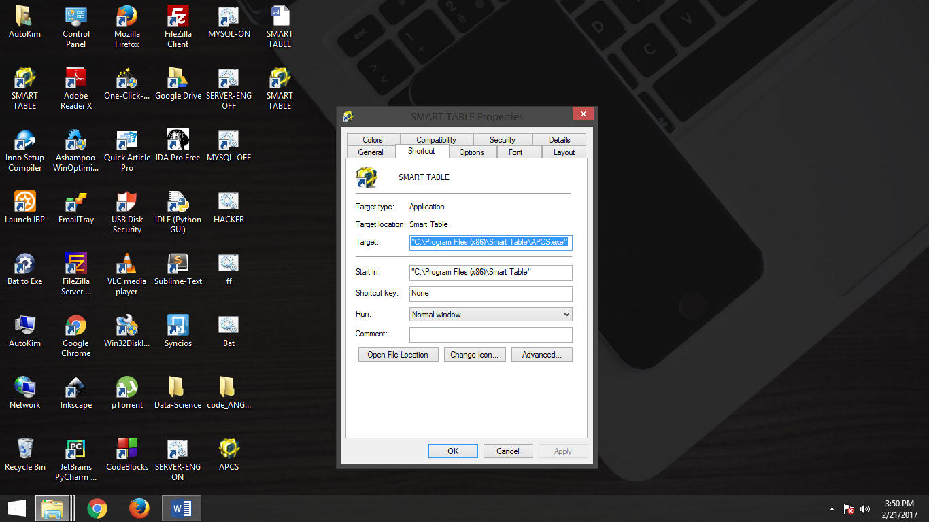

-For the Application to run Efficiently and in its screen size,you need to ensure you make the Settings as follows:

-Click on Layout menu on the above window

-Change the values to be exact as the following:

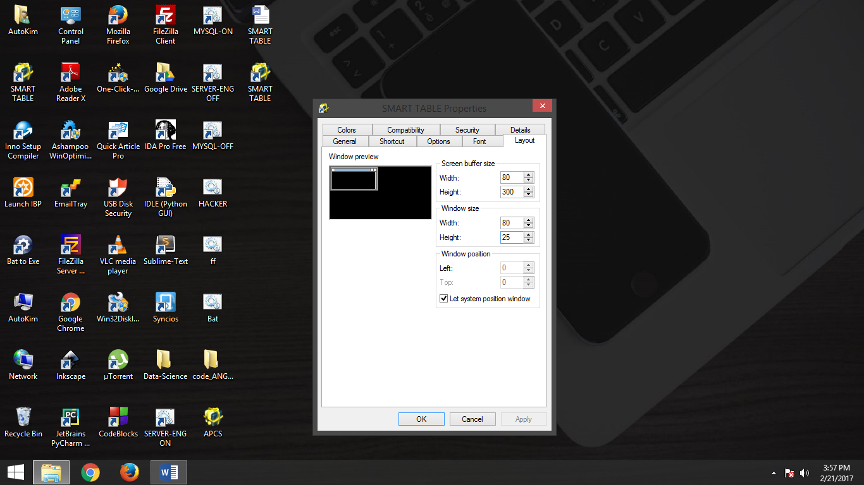

-You can change the application text color or background color

-Click on Colors tab as below….and make your changes

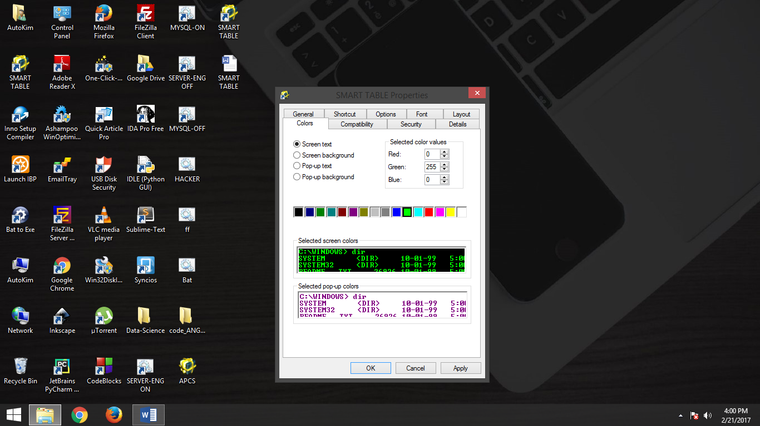

>>>>>FOR ANY OTHER TECHNICAL ISSUES OR FAILURE;

CONTACT US : +254724097929

CURRENTLY OPERATING IN MULTIMEDIA UNIVERSITY OF KENYA

FACEBOOK PAGE : Young Computer Wizards & Innovators

PAGE DIRECT LINK : fb.me/youngcomputerwizards

**THANKS FOR CHOOSING SMART TABLE SOFTWARE!**